**Graphics and Animation Tools**

**LAB - VIVA**

**Design of Spectacles Using GIMP**

**Step-1**

Go to File → New enter the dimensions as 800 X 500 px.

**Step-2**

Download and save any Image from the Internet of spectacles and then File  → open as layer, then select the same image.

**Step-3**

Select the free select tool on the panel left side or by using shortcut as F and outline the inner part of spectacles where glass comes.

**Step-4**

Now go to Select → To path, then go to paths on the right bottom panel and right-click on the path → Path to selection, and at last select a color and then Edit → Fill as Foreground/Background color.

**Step-5**

Repeat the Step-3 and Step-4 for the frame of the spectacles.

**Step-6**

Now Draw a triangle along the diameter by using free select tool to make it more attractive and then color it as well.

**Google Drive Link-**

<https://drive.google.com/drive/folders/1hXI4eib7AgVxa5ah3hwn6goBlxM8eXCf?usp=sharing>

**Output-**

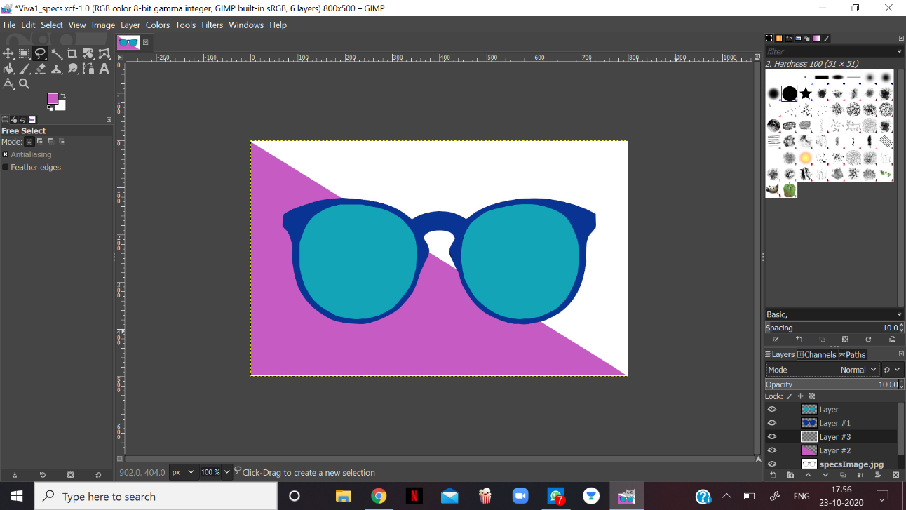

**Graphics and Animation Tools**

**LAB - VIVA**

**Design of 3-D Laptop Using Blender**

**Step-1**

Create a new project and clear everything from the interface.

**Step-2**

Go to Add → Mesh and add a cube, change the dimensions to 1.5 X 2 X 0.05 to resemble the base of laptop .

**Step-3**

Enter edit mode and add loop cuts such that to differentiate the keyboard area, trackpad area and speaker area.

**Step-4**

Now, select the face select mode and select the area for keyboard and extrude it inside to give it depth by pressing E and then Z.

**Step-5**

Repeat the Step-4 again for the trackpad and for speakers on both the sides.

**Step-6**

Now go to Add → Mesh and add a cube, change the dimensions to 0.1 X 0.1 X 0.02 to resemble the keys of the keyboard and then duplicate ( Shift + D) the same key multiple times to make the full keyboard.

**Step-7**

Now go to Add → Mesh and add a cube, change the dimensions to 0.02 X 0.02 X 0.02 to resemble the holes of speaker and then duplicate ( Shift + D) the same cube multiple times to make the speaker look more realistic. Repeat the same for the other side speaker.

**Step-8**

Now to make the hinge which attach the laptop base and screen go to Add → Mesh and add a cube, change the dimensions to 0.03 X 0.3 X 0.1 and place at the end of the laptop’s edge. Duplicate ( Shift + D) this and add it on the other side too.

**Step-9**

Now create the screen part of the laptop of similar dimension as the base as mentioned in Step-2 and add loop cuts and extrude the face inside like in Step-4.

**Step-10**

Now go to Shading mode and add the color according to your preferences, and your 3-D model of laptop is ready.

**Google Drive Link-**

<https://drive.google.com/drive/folders/1hXI4eib7AgVxa5ah3hwn6goBlxM8eXCf?usp=sharing>

**Output-**